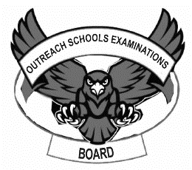**OUTREACH SCHOOLS EXAMINATION BOARD**

**MIDTERM II EXAMINATION 2023**

**Age Group (3 – 4 years): BABY CLASS**

**Learning Area 3: Health Habits**

My name is __________________________________________

1. **Match the same.**

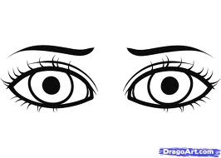 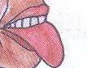

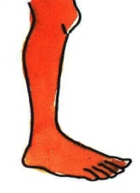

 



1. **Shade the dangerous objects.**

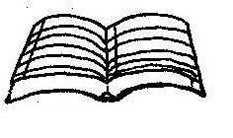 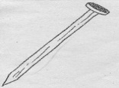 

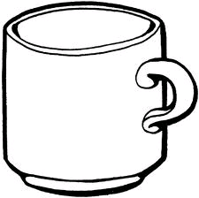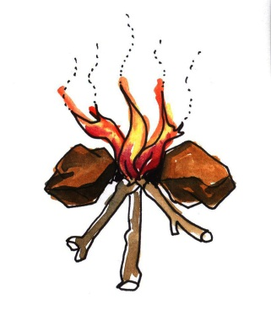

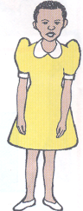  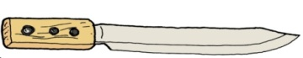

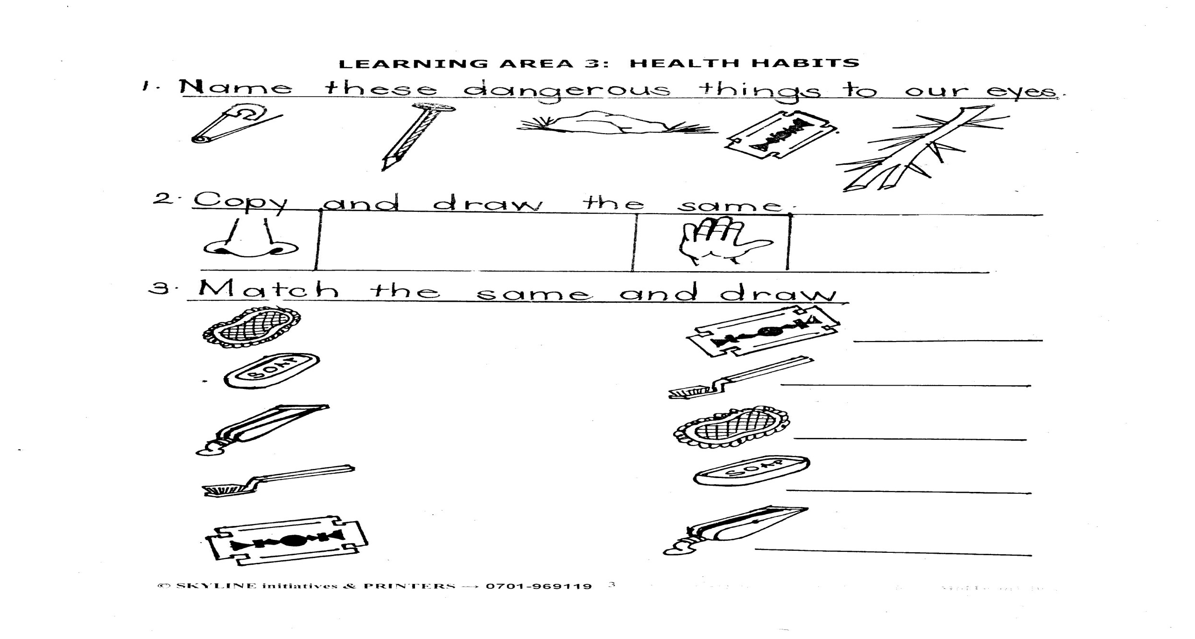

 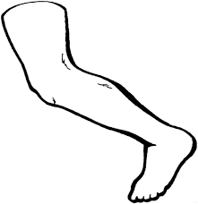 

1. **Copy and draw the fruits.**

|  |  |  |
| --- | --- | --- |
| Apples Coloring Pages | D:\DESKTOP BACKUP\assesst\SAM PICTURES\SAM PICTURES2\fruits\orange.jpg | C:\Users\abc\Desktop\Oasis\desktop\STELLA FILES AUG 2015\STELLA PICTURES 2015\p1-extension 2\PICTURES MATHS & ENGLISH\Mango - 1.jpg |
|  |  |  |
| D:\DESKTOP BACKUP\assesst\SAM PICTURES\SAM PICTURES2\foods\melon.jpg | D:\DESKTOP BACKUP\assesst\SAM PICTURES\SAM PICTURES2\fruits\banana.png |  |
|  |  |  |

1. **Circle the same.**

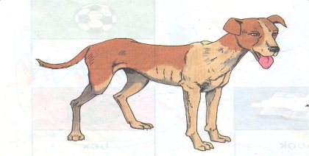 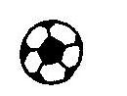 

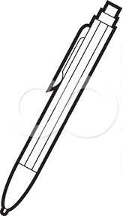

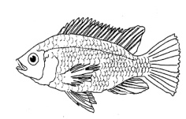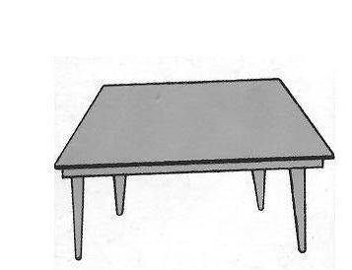

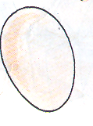  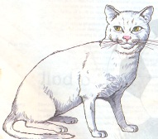

**End**